Storage classes in c language
____________________________________________________
storage classes are the some keywords which is used for decide the variable default value , variable storage area, variable scope and variable life called as storage classes

There are four types of storage classes
1. auto : auto storage class is a default storage class means every local variable work with auto storage class.

keyword: auto
default value: garbage
scope: within block
life: within block
memory storage area : stack

#include<stdio.h>
void show()
{
printf("A = %d\n",a);
}
int main()
{
auto int a; //auto int a;
printf("\n\nA=%d\n",a);
show();
return 0;
}//
Note: above code generate compile time error to us because
we have variable a with auto storage class and we declare variable within main function and trying to access in show() function so it is not possible because variable a has scope within main function

2. static:
keyword: static
default value: 0
scope: within block
life: through the program
storage area: data segment

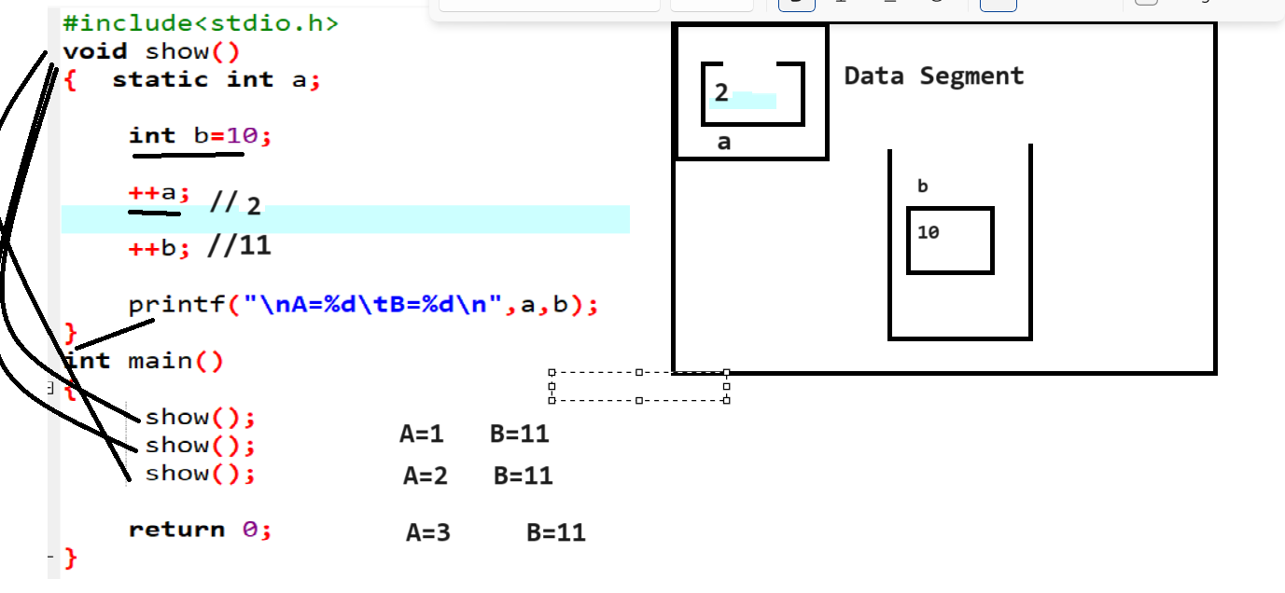
3. extern :
keyword: extern
default value: 0
storage area: data segment
life : thorugh the program
scope: through the program
Note: extern keyword use when we want to share the global
comman value between local and global variables
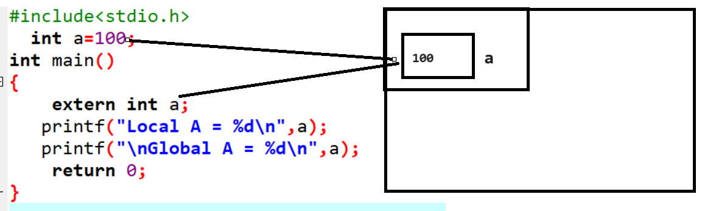
4. register
keyword: register
default value: garbage
scope: within block
life : within block
storage area: CPU buffer memory

#include<stdio.h>
int main()
{ register int a;
printf("Local A = %d\n",a);
return 0;
}
Pre processor directives and macro definition
_______________________________________________
Q. what is pre processor directive?
Preprocessors are programs that process the source code before compilation. A number of steps are involved between writing a program and executing a program in C / C++. Let us have a look at these steps before we actually start learning about Preprocessors.
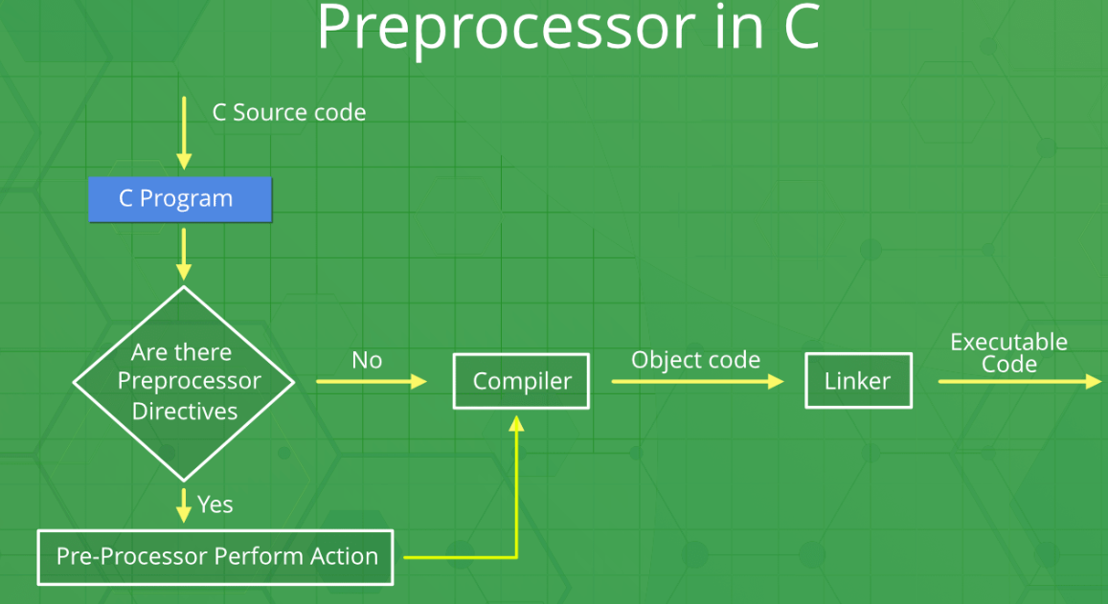
You can see the intermediate steps in the above diagram. The source code written by programmers is first stored in a file, let the name be “program.c“. This file is then processed by preprocessors and an expanded source code file is generated named “program.i”. This expanded file is compiled by the compiler and an object code file is generated named “program.obj”. Finally, the linker links this object code file to the object code of the library functions to generate the executable file “program.exe”.
Preprocessor Directives in C/C++
Preprocessor programs provide preprocessor directives that tell the compiler to preprocess the source code before compiling. All of these preprocessor directives begin with a ‘#’ (hash) symbol. The ‘#’ symbol indicates that whatever statement starts with a ‘#’ will go to the preprocessor program to get executed. We can place these preprocessor directives anywhere in our program.
Note: Remember that the # symbol only provides a path to the preprocessor, and a command such as include is processed by the preprocessor program. For example, #include will include the code or content of the specified file in your program.
Preprocessor Directives | Description
#define | Used to define a macro
#undef | Used to undefine a macro
#include | Used to include a file in the source code program
#ifdef | Used to include a section of code if a certain macro is defined by #define
#ifndef | Used to include a section of code if a certain macro is not defined by #define
#if | Check for the specified condition
#else | Alternate code that executes when #if fails
#endif | Used to mark the end of #if, #ifdef, and #ifndef

Types of pre processor directive
____________________________________________
1. file inclusion : this is used for include the library in c program using header file
#include <filename.h>
or
#include “filename.h”

2. Macro definition: macro definition is denoted by
#define keyword and it is used for declare the constant in code as well as execute the single logic and reuse it
Syntax:
#define macroname value;
Example: #define MAX 100
#include<stdio.h>
#define MAX 100
int main()
{ printf("\nMAX is %d\n",MAX);
return 0;
}
if we think about macro using a macro you can set special symbol as constant value.

#include<stdio.h>
#define P +
int main()
{
int a,b,c;
a=100;
b=200;
c= a P b;
printf("Addition is %d\n",c);
return 0;
}
You can execute single line logics using a macro definations
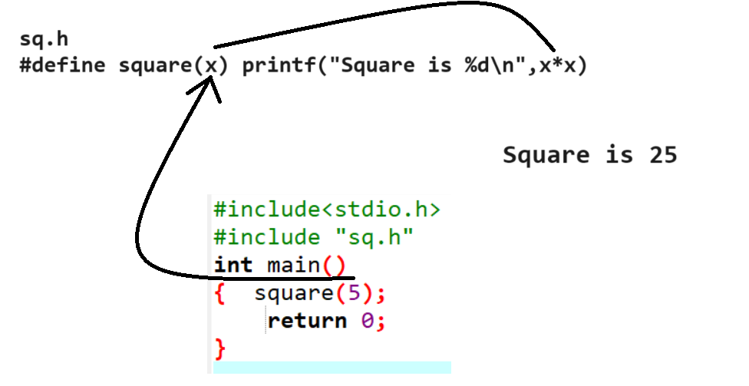
3. Conditional compilation:
Conditional compilation is used for to check the condition with pre processor directives
#if – simple if
#else – simple else block
#elif – if else block
#endif – close if
Note: when we work with conditional compilation then we not required to use opening and closing block.

#include<stdio.h>
#define A 100
#define B 200
int main()
{ #if A > B
printf("A is GReater");
#else
printf("B is Greater");
#endif
return 0;
}
typedef : typedef is keyword using that you can create own
data type.
#include<stdio.h>
#define A 100
#define B 200
int main()
{ typedef int a;
a b=100;
printf("\nB=%d\n",b);
return 0;
}

